**Part 1. Aircraft Maintenance System**

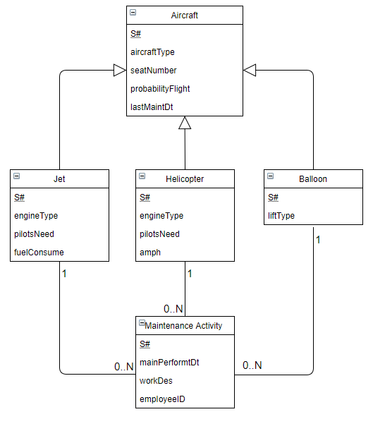

**S# :** Unique Serial Number

**aircraftType** : Type of Aircraft

**seatNumber** : Maximum amount of seats

**probabilityFlight :** Probability of Successful Flight

**lastMaintDt :** Last Maintenance Date of Airship

**engineType :** Engine type of the aircraft

**pilotsNeed :**  The amount of pilots needed to man the aircraft

**fuelConsume :** Fuel consuption ration

**amph :** Amphibious/ Can the airfract land on water or not

**liftType :** The type of lift mechanism

**maintPerformDt :** The date the maintenance activity was performed

**workDes :** Description of the work done on the aircraft

**empIoyeeID :** The ID of the employee that carried out the activity

**Part 2. Airline Reservation System**

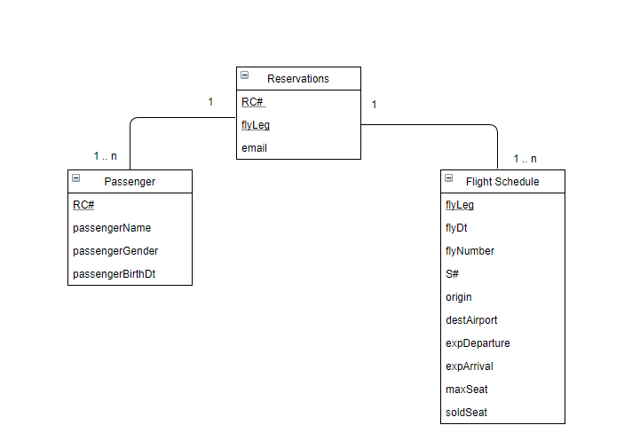

**RC#** : Reservation confirmation number

**flyLeg** : current flight of a reservation

**email :** email associated with a reservation

**passengerName :** Passenger’s name

**passengerGender :** Passenger’s gender

**passengerBirthDt:** Passenger’s birthdate

**fltDt:** Date of the flight leg

**flyNumber :** Flight leg number

**S# :** Airplane’s serial number

**origin :** Origin airport

**destAirport :** Destination airport

**expDepature :** Expected departure time

**expArrrival :** Expected arrival time

**maxSeat :** Maximum amount of seats available

**soldSeat :** Number of seats sold for the flight leg